**The required updates: Every updates listed beneath must be in separated package**

1. **First mini project:** Updating current python version with the following:
   1. To apply network intrusion detection dataset found in <https://www.kaggle.com/sampadab17/network-intrusion-detection>
   2. To apply Breast Cancer Wisconsin (Diagnostic) Data Set found in <https://archive.ics.uci.edu/ml/datasets/Breast+Cancer+Wisconsin+(Diagnostic)>

Budget: 100 USD

1. **Second mini project:** Add k-nearest neighbors for kernel selection

Budget: 200 USD

1. **Third mini project:** Replace standard SVM in GF Python toolbox with LSVM
   1. Python code of LASVM: <https://leon.bottou.org/projects/lasvm#introduction>
   2. The figures to be added as in paper “Fast Kernel Classifiers with Online and Active Learning” link: <https://leon.bottou.org/publications/pdf/jmlr-2005.pdf>

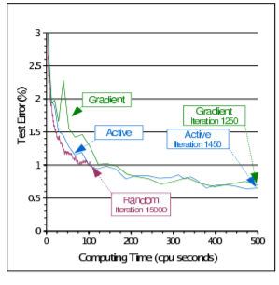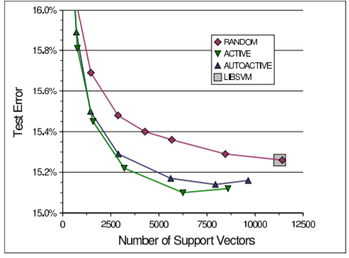

Budget: 200 USD